Towards a Smart City with Smart Traffic Lights
By: Selina Dersarkissian

Introduction
One of the biggest issues faced to our day to day in Jordan is traffic and most of our days are spent on roads. Traffic causes many accidents and leading to injuries and fatalities. It also wastes times, fuel and productivity.
Consequently, I decided to dedicate my project to lessen the chance of traffic at car districts were most accidents happen.
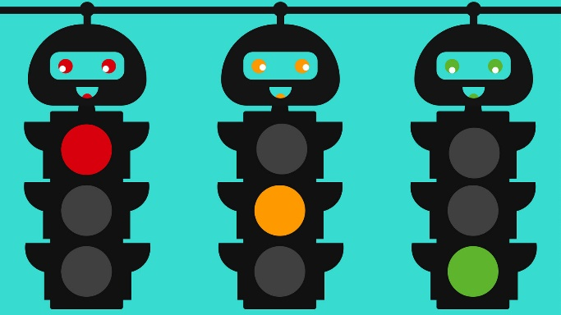
Traffic lights work dependent on time set for each light with a certain time set for green, red and orange lights and the cars move accordingly. However, at many times especially in districts, a certain road has more traffic than the other and should have the priority to move instead.
Thus, my project is a smart traffic light that works according to car density rather than time to reduce traffic.

Background and Literature Review
Smart cities are cities that depend on information and communication technologies (ICT) to improve the quality of life for citizens by enhancing governmental services, increasing the operational efficiency and sharing information with the public.
Accordingly, a smart traffic light would be necessary in a smart city as it would increase operational efficiency, save time, enhance the quality of roads and thus make the citizens life better.
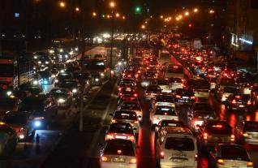
After thorough research, car traffic is a major issue in Jordan, that is faced on a day to day basis. There is concern about the number of vehicles on roads as estimated to over two million and 100 thousand vehicles, according to a study by Wafai Msis, Head of the Jordanian Society for Road Accident Prevention. Imagine the density on roads! This big density leads to immense traffic on traffic lights and districts. Moreover, as evident in a study by Riyad Kharabsheh, executive director of Public Transport and Infrastructure Transport Projects at Greater Amman Municipality (GAM), “Delays caused by traffic congestion in Amman cost an estimate of JD1.5 billion annually, which takes into account the costs of fuel and time.” This is an outstandingly huge amount lost! For that I came up with the idea of smart traffic lights that are density based to avoid spending useless hours that could waste productivity, as well as waste expensive fuel in immense traffic.

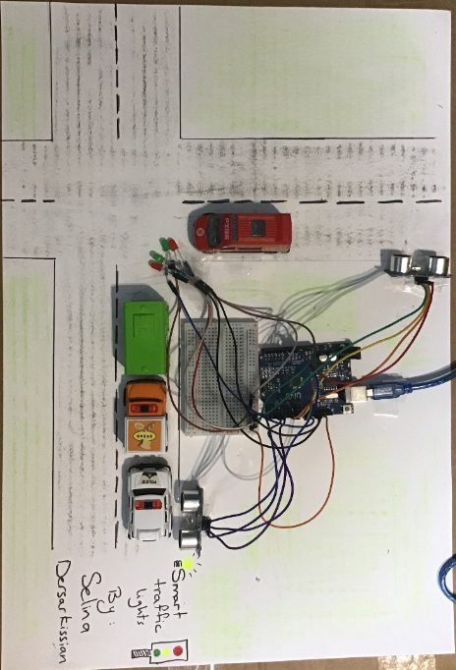
Solution
My smart traffic light works according to density of the cars. Using its Ultrasonic sensors on each end of a district, it can measure the greater value of cars and accordingly switch the colors of the traffic light, giving priority to the more dense amount of cars.
This works by detecting the capacity of cars and sending the information to the microcontroller (Arduino UNO), then the glowing of the green light is prioritized. This reduces traffic congestion and saves time wasted in traffic.

- Components
- Two Ultrasonic Sensors
- Two red LED lights
- Two green LED lights
- Four resistors
- One breadboard
- One UNO arduino microcontroller
- Sixteen male/female jump wires
- Two standard wires

- Code
void setup() {
// put your setup code here, to run once:
pinMode(9,OUTPUT);
pinMode(10,OUTPUT);
pinMode(12,OUTPUT);
pinMode(13,OUTPUT);
pinMode(7, OUTPUT);
pinMode(6, INPUT);
pinMode(3, OUTPUT);
pinMode(2, INPUT);
}

void loop() {
// put your main code here, to run repeatedly:
long duration, distance;

digitalWrite(7, LOW);
delayMicroseconds(2);
digitalWrite(7, HIGH);
delayMicroseconds(10);
digitalWrite(7, LOW);

duration = pulseIn(6, HIGH);

distance = (duration * 0.0343) / 2; // Calculate distance in cm

long duration2, distance2;

digitalWrite(3, LOW);
delayMicroseconds(2);
digitalWrite(3, HIGH);
delayMicroseconds(10);
digitalWrite(3, LOW);

duration2 = pulseIn(2, HIGH);

distance2 = (duration2 * 0.0343) / 2; // Calculate distance in cm

if(distance==distance2){
digitalWrite(9,HIGH);
digitalWrite(10,LOW);
delay(20);
digitalWrite(12,HIGH);
digitalWrite(13,LOW);
delay(20);
}
else if(distance>distance2){
digitalWrite(9,HIGH);
digitalWrite(10,LOW);
delay(20);
digitalWrite(12,HIGH);
digitalWrite(13,LOW);
delay(20);
}

else if(distance<distance2){
digitalWrite(10,HIGH);
digitalWrite(9,LOW);
delay(20);
digitalWrite(13,HIGH);
digitalWrite(12,LOW);
delay(20);
}
delay(3000);
}

Data Analysis and Results
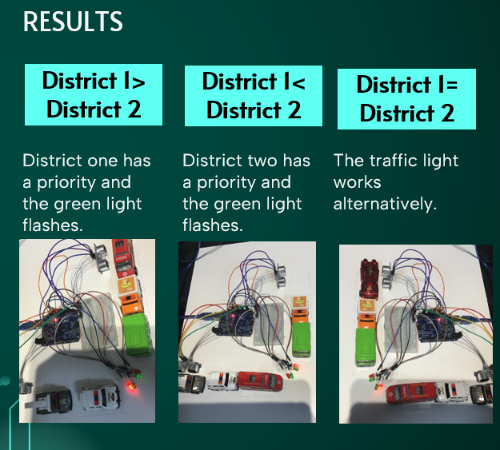
Based on the data collected from my trials; the two ultrasonic sensors measure the distance then sends the data to the microcontroller in which it compares in the code which is greater. The district with the greater distance means there is less traffic and thus remains red, and the one with the less distance turns green to give priority for the cars in the crowded district to move. If both are equal, the traffic lights work alternatively.
Conclusion

In conclusion, to eliminate the long ques in traffic jams, for example on districts; my smart traffic light works on car density on the road rather than set time. Using its ultrasonic sensor, it is able to measure which district has more capacity of cars and allow the more crowded one to have priority in moving.

Future works
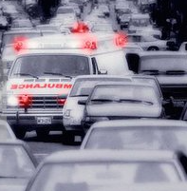
In the future, to further elaborate on my idea of smart traffic lights and to contribute in solving car traffic issues; a great addition to the project would be adding a sensor on traffic lights that detects waves of signals with those signals attached on ambulance cars in order to turn green and give priority for the ambulance to pass in order to ensure that the patient reaches the hospital on time without delays.

Citation
“Jordan Loses One Life Every 16 Hours Due to Road Accidents.” RoyaNews, en.royanews.tv/news/44491/2023-09-15. Accessed 18 Apr. 2024.
(PDF) Daily and Monthly Expansion Factors for Traffic Volumes In ..., www.researchgate.net/publication/330497584_Daily_and_Monthly_Expansion_Factors_for_Traffic_Volumes_in_Amman-Jordan. Accessed 18 Apr. 2024.
Long-Term_national_transport_strategy_project.PDF, www.mot.gov.jo/EBV4.0/Root_Storage/EN/EB_Info_Page/long-term_national_transport_strategy_project.pdf. Accessed 18 Apr. 2024.
Tamara Abdin, Jordan News, and 2021 last updated: Apr 05. “Traffic Congestion Losses Amount to JD1.5 Billion Annually - Jordan News : Latest News from Jordan, Mena.” Jordan News | Latest News from Jordan, MENA, 5 Apr. 2021, www.jordannews.jo/Section-106/Features/Traffic-congestion-losses-amount-to-JD1-5-billion-annually-963.

Thank you!

